Launch an EC2 instance (Linux and Windows) along with a web server. Then, create an EBS volume of 5 GB, attach it to an EC2 machine (Linux and Windows), and take a snapshot. Finally, create an EBS volume using the taken snapshot.
Linux instance with volumes
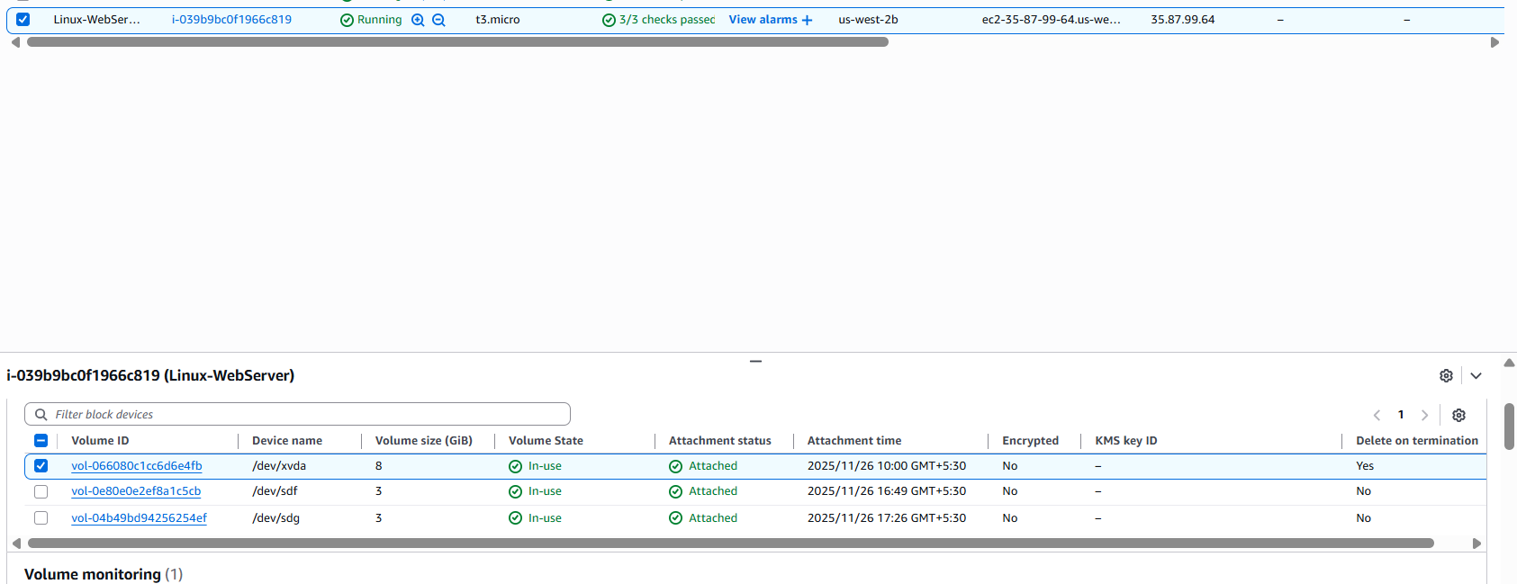
Snapshot attached to 3 volumes
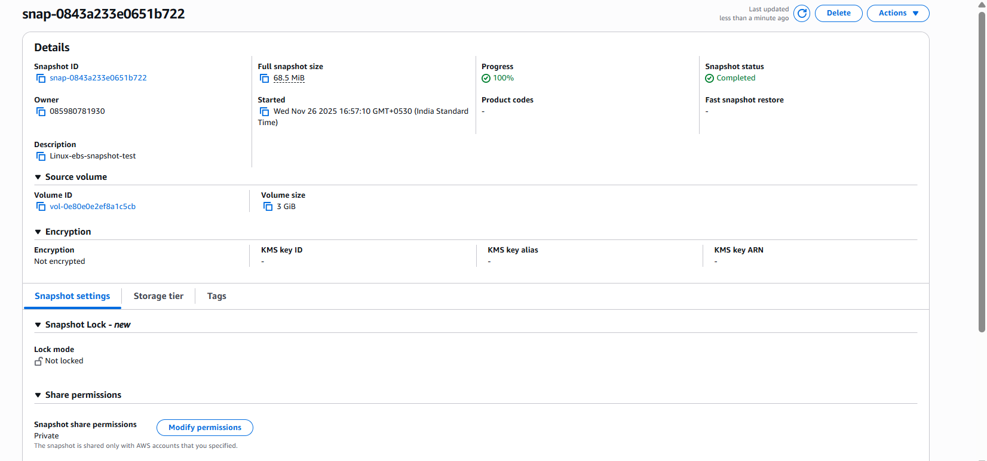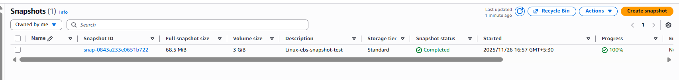
Linux SSH session and moutpoints
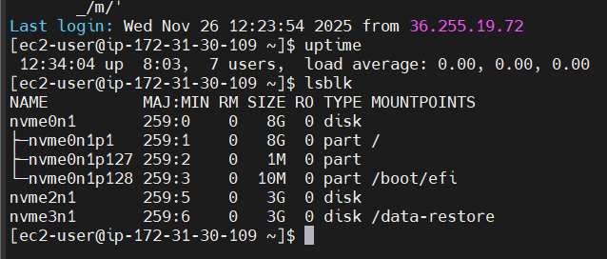
Volumes
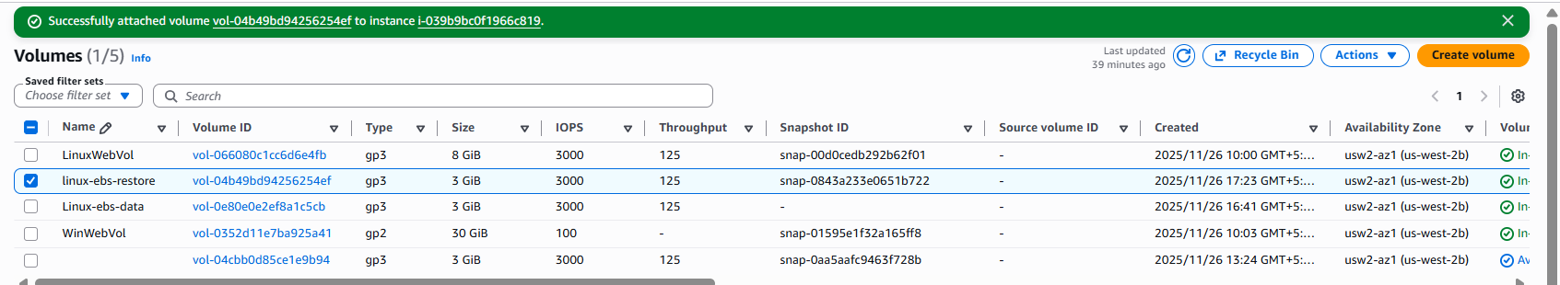
Windows Volume
